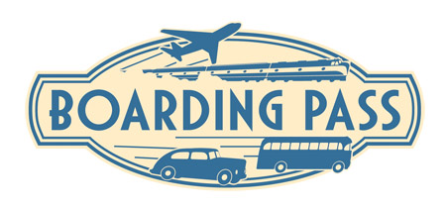



Proctorville Animal Clinic Boarding Form

Pet's Name ___________________________ Owner's Name _________________________

Today's Date _________________________ Return Date ___________________________

**All boarders MUST be picked up from our facility within these time frames:
Monday - Friday from 9:00 a.m. - 5:30 p.m. and on Saturday from 9:00 a.m. - 11:30 a.m.**

- Would you like your pet to have a bath and toe nail trim before going home? YES  NO 
(**If so, you MUST pick up your pet after 3:00 p.m., Monday - Friday**)

- Is your pet currently taking any medications? YES  NO 
Medication | Dosage Instructions | Condition Treated

- Does your pet need to see the veterinarian while boarding with us?
________________________________________________________________________
- If you are leaving food for your pet, what are your feeding instructions?
________________________________________________________________________
- Are you leaving any: toys, blankets, leashes, etc? Please list all items...
________________________________________________________________________
- If you have more than one pet, do you want them boarded together? YES  NO 

- Is there a person authorized to make all medical decisions for you in case you cannot be contacted, including any treatments or euthanasia (putting your pet to sleep)? YES  NO 
Emergency contact name ________________________________________
Emergency contact telephone number ______________________________

- In the event that no one can be reached, do you authorize the veterinarian to perform workup / treatment as necessary for my pet's well being in an emergency situation (up to $200.00)?
YES  NO 

